Best Western Plus Steeplegate  100 W. 76th St  Davenport, IA 52806  A block of rooms has been reserved at a discounted rate. Tell them you are with the Iowa State Assembly when you book your room | Iowa Assembly of Surgical Technologists  P.O. Box 1724  Des Moines, IA 50305-1724 |  | Iowa Assembly of Surgical Technologists  Fall 2017 Business Meeting and Workshop  Saturday September 16th 2017  Best Western Plus Steeplegate  Davenport, Iowa  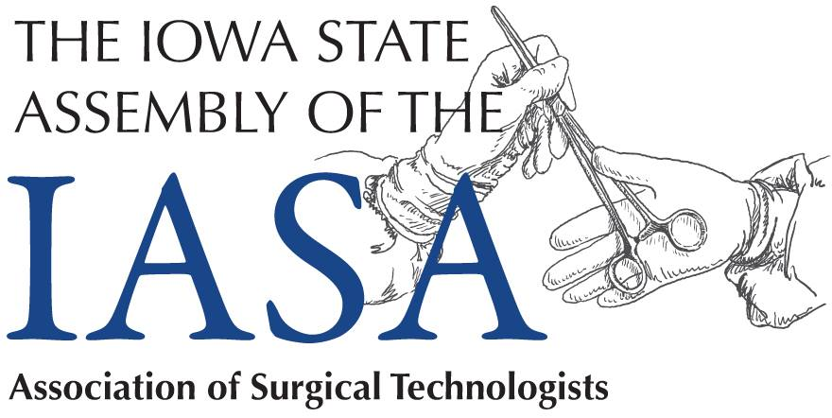

Schedule for the Workshop  900-910 Welcome and Introduction  910-1000 Anita Hadley CRNA  Anesthesia for Diverse Patient  Populations  1010-1100 Betty Baker CST  Communication in the OR  1100-1115 BREAK  1115-1205 Dr. Siva Elangovan  Sinus Surgeries  1205-1255 Lunch and Business Meeting  1255-145 Dr. Sundar  Surgical Procedures for  Back and hip nerve pain  145-235 Dr. Christian Erickson PharmD  Medications and Pharmacology  235-255 BREAK  255-345 Dr. Pavlina Kemp  Strabismus (Eye) Surgery  345-435 Tiffany Erickson CST  Iowa Assembly Q and A  435-455 Closing and CEU’s | Please detach this portion and return with payment.  Name _______________________  Address ______________________  City __________ State ___ ZIP____  NBSTSA Cert. Number ___________  AST Membership Number _________  Credentials  Circle those that apply  CST CST/CSFA LPN RN  Other_______  Email _________________________  Fee  AST Member $45  Non Member $55  Student $10 | Contact Us  Iowa Assembly of Surgical Technologists  P.O. Box 1724  Des Moines, IA 50305-1724  Ia.ast.org  Contact Information  Toni Steward  3800 Avenue D  Council Bluffs, IA 51501  402-689-7460  tsteward@iwcc.edu

